Business Case Analysis

of

SMART KEY SYSTEM

Michael Fetick - 84270

Weilong Qu - 660162539

Bobby Ray Hurd - 76210

Yuxuan Guan - 660161473

Nithin Garrepally - 73600

Sheraz Karim - 660161500

Coleman University

Table of Contents

Table of Contents 2

LIST OF FIGURES 4

Abstract 5

Overview 6

Identifying opportunity 6

Determine objectives 7

Determine Alternatives 7

Collect and Arrange Data 9

Review Data 12

Considering the Intangibles 13

Implementation Plan 15

Research (3 months) 16

Product Planning (2 weeks) 16

Product Design (2 Months) 17

Product Productions (4 Months) 18

Marketing Strategy 18

Marketing Targets 18

Customers 18

Stakeholders 19

Partnership 19

Marketing Materials & Promotions Strategy 19

Market Budget 20

Measured Success 20

Internally…………………………………………………………………………………………24

Conclusion 27

References 28

LIST OF FIGURES

Figure 1 Review Data …………………………………………………………………………13

Figure 2 Market Budget …………………………………………………………………………20

Abstract

This paper is focused on Analyzing and Developing Business Case around automobile system called "SMART KEY SYSTEM". Current paper explains about different opportunities, alternatives, implementation plan and marketing strategies developed by our team in order to make this product success. We also looked into the Priceline of different products available in the market and developed strategy to produce a product with lesser price.

(***Key words*:** Determining Alternatives, Implementation Plan, Decision Making, Marketing)

Overview

Security is one of the major issues that need more attention in today’s globalized world. Utilizing technology to develop security is always a challenging task, as one should think of all the possibilities of protecting their system. Our current project is focused on similar idea of developing a security system within the automobiles to make customer more comfortable about his product. One of the major security problems we observed in automobiles is a problem to identify whose car or truck is honking in the parking lot when a suspicious person touches it while the car is locked and this is a major confusion and problem for many customers. In order to overcome this we developed a product called “Smart key”. Based on these ideas we started looking into the available opportunities, objectives, alternatives and business development plans to grow our business.

Identifying opportunity

We started our journey understanding the customer needs and consumer behavior within the automobile industry. As our product is about creating security to automobiles, at the very first step we were able to identify our opportunities and started explaining the use of “Smart Key” technology to different manufacturing companies within the United States. Apart from regular car manufacturing companies we also identified other third part automobile distribution companies to help customers who wanted to install this security system within their old cars. In order to overcome certain confusions we came up with set of requirements that cars need to have before installing this security system. Also we thought of working with auto insurance companies and provide some discounts to customers who have this equipment installed in their cars.

Determine objectives

As a startup company we have many growth objectives to focus on for the 2015, one of the most import among them is to develop a well establish marking plan to get more potential customers, increasing manufacturing and inventory facilities, focus of existing customers and provide timely maintenance or support if required, identifying new opportunities to increase sales.

Marketing is the key factor for small scale industries, as getting more consumers is main step for product success. Considering the potential risks established within the industry, we looked into different marketing structures like reaching out to customer and providing a live demonstration publicly their by creating awareness of our security system, so they can look for this options when they want to buy new cars and also by registering the customers and promising a delivery time to get it installed in their existing cars. A part from this idea our marketing analysts will also focus on reaching out to the automobile industries and explaining the product features.

Our long term plan is to be committed to accelerate our pace of progress, developing product excellence and driving innovation in all areas of our business. We are always focused on developing a great quality product in cheaper price. As there are already similar products available outside in the market which utilizes satellite communication system to track your car, our system is more unique, cheaper and easy to install.

Determine Alternatives

Smart key is new technology that will facilitate customer to remain in contact with his car round the clock from certain distance. To achieve our goal we study functionality of different pre-existing central locking and car security system like automatic door locking system and Viper Responder security that beeps and sends text message to the user if the engine is running, if the door has been opened, or left is unlocked. The website chose the Viper Responder 5901 car security system as the top pick on its 2013 best Car Alarm Security System list. We consider different alternatives for cost effective and affordable systems for all class of customers. Similarly, we closely examine performance of key for log and short range distance. Our main objective was to give customer a cost effective and efficient product that can able to work most effectively from long distances.

However, after profound study and research all factors at every level we come to the conclusion that we should use radio frequency which is cheaper as compare to satellite based network or embedded modem in car, Which could be cost effective and efficient in working perspective. The body controller is a computer in car, that care different key functionality of car as well as many little things which makes car friendly at every level to meet and exceed customer satisfaction for instance it kept on interior lights on until car start and kept main keys ignition. Similarly, it keeps body monitors for all possible lock or unlocks signals. It monitors through radio frequency and unlock the door when it receives the correct digital code and radio transmitter in key.

We will use different alternative options like use a chip in car that will directly connect with car computer and central sensor system which transmit signal to our mobile in form of text or beep, if in case someone try to damage or open the car to stolen. Similarly, the other option is to build a modem in car that will connect one way to car computerized central security system and also satellite by using mobile network to receive text and beep message that will identified user about his car possible security threats.

We will use for three different type of alternatives to control the car sensor and control system like we categorized on the basis of cars and different class of customers. For instance high profile rich people having luxurious cars like BMW, Lexus, Acura, and sports cars we will use satellite network and for middle class we will use built in modem which will cost one time investment for cars like Toyota, Honda, Ford, Hyundai etc. Similarly, for lower class with outdated cars we will use infrared that will work only from certain limited distance.

Collect and Arrange Data

Various data are required for analyzing our business. These data are critical as they are the base of our analysis and decision. The accuracy of these data are key to success. Also data ranging from marketing to labor are all necessary as each factor can play a significant role at various phrase of the business. Carefully collect and arrange data can help us make reasonable and trustworthy analysis and furthermore make correct business decision and finally leading to business success.

We collect data from following perspectives. We try to cover all aspects of a business. If we found something missing during the execution of business we can add them quickly.

Data about marketplace needs

Data about productivity and services to meet these needs

Data about consumers

Data about business organization and labor

Data about investment and expense

By 2012, the data from all the State’s Department of Motor Vehicles (DMVs) show there were 253M vehicles registered in the United States (Laudon & Traver, 2012). And the number of cars is still increasing. Last year, 2014, 15.6 million vehicles were sold in the United States. This market is getting huger and huger. Most them are being threaten by car stealing or break in. According to the FBI, a motor vehicle is stolen every 44 seconds in the United States. In 2013, FBI reported there were an estimated 699,594 motor vehicle thefts nationwide. (n.d. 2014)

A survey of American drivers conducted in April 2007 found about 21% people forget to lock their vehicles sometimes and 7% people even leave a spare key in their vehicle ever. If we estimate 50% of the vehicles are being used that means about 126M vehicles need our protection. That is a huge market! Some market key data are listed below

Total vehicles in the United States 253M

Estimated vehicles on active service 126M

Number of stolen annually 699K

We are not able to install our system on all of the cars as several competitors are also providing good service. We estimate 10% car owner would like to buy a car safety product and 10% of them would like to purchase our product, SMART KEY. That means our market is about 2.53M smart key subscriber.

To make our product more popular, a comprehensive study on current available product pricing is required. Here are some data about the price of current popular car anti-theft product.

Mechanical Immobilizers $10 ~ $100

Steering-Wheel Lock $25 ~ $100

Hood Lock $20 ~ $50

Tire Lock $80 ~ $200

Gearshift locks $25 ~ $100

Electronic Immobilizers $100 ~ $150

Kill Switch $10 ~ $200

Car Alarm $150 ~ $1000

Vehicle Tracking $200 ~ $1500

We can notice the most popular price range is ranging from $20 to $200. We have to consider to control the cost and price to meet this price range.

Competitors are also making their efforts to gain profits from this market. I cannot ignore their capability and competence. Here are some data about our potential competitors.

LandAirSea GPS Tracking Device $149

Mast Track GPS Tracker $98

Viper Responder Remote $65

Astra ASTRA4000RS $62

Data about Regulatory Restrictions

Since our product can transmit wireless signal the transmitter must meet regulatory restrictions, such as FCC requirement. Basically, our product has to run at a free frequency that means we do not need to pay it and no special license required to operate in that. But special transmitting power is restricted. But every country has their frequency management policy. We must comply with them. No-license frequency can be looked up from the following map (n.d. 2010)

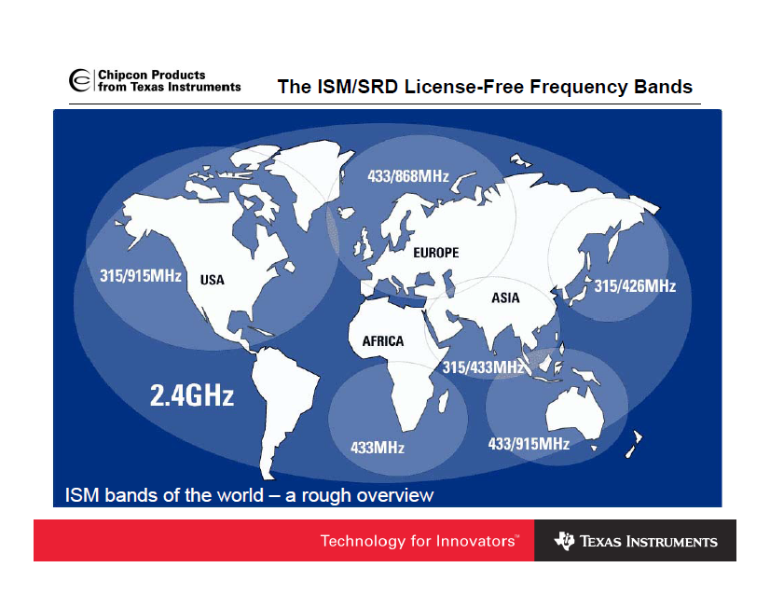

Review Data

Here are the summary of data collected and analyzed

Data about market needs

Total vehicles in the United States 253M

Estimated vehicles on active service 126M

Number of stolen annually 699K

In summary 1% vehicle would buy our product, SMART KEY. That is to say, our product volume will be about 2.5M.

Data about production and service

Research and Development expense $50M

Investment of equipment and facility $50M

Data about company

Number of employee 5

Salary $100k each

Data about product marking estimation

Price $100/pcs

Cost $20/pcs

Service expense $3/pcs

Data about profit

Annual Sales $250M

Profit $50M

Considering the Intangibles

Citizens that trust their vehicle alarm system will feel more secure to keep expensive possessions inside their vehicle. Theft intervention is the essential benefit that our product provides. But it relies on two critical factors: 1) the response of the owner, 2) the duration of the theft event. Some people keep many items in their vehicle for convenience. While others keep minimal possessions in their vehicle for reasons of security. All others, fall in‑between their decision of necessity and convenience versus security. The best case, in the event of an attempted theft, will beg the questions, “Was the property out of sight?” and “How good is the vehicle security/alarm system?”

The intangibles are subjective factors that are important to consider. Their analysis is made easier, because of the previous work by others that have come before us. The basic technology of our product is an incremental innovation of existing technologies. The intangibles evaluated are the market interests, potential expansion, political implications, partnerships, and risks. The proceeding paragraphs describe each of these intangible factors.

The market interests is fundamentally the ‘demand’ portion of the supply-demand economic equation of market movements. These interests are examined to identify who is interested, who are unaware they are a possible beneficiary, and potential future beneficiaries. Commuters will carry essential and critical items for pleasure, work, and business. Travelers will carry luggage and valuables in their vehicles and towed trailers. Utility trucks used for skilled trades, such as general-laborers, cable/security system installers, electricians, carpenters, plumbers, locksmiths, sales representatives, etc carry a large volume of property, essential for their business. These items include expensive tools, supplies, and merchandise. There is great potential for fleet sales of our product. Delivery trucks carry consumer goods by bonded carriers, such as UPS, FedEx, and the USPS. Tractor-trailer (over-the-road) operators carry cargo inside their trailers. Inside their tractor cabs they have expensive electronic devices for GPS navigation, tool‑booth transponders, CB‑radios, televisions, refrigerators, and generators. All the property of these vehicle operators are exposed and need to be protected from theft.

The potential expansion is a plan for additional product models in the line of products. It also foresees further growth into other markets and the subsequent creation of a family of products in the product line. New products that expand the market, can be developed and launched later. Such a product can be ‘attached’ to existing vehicle alarm systems of our competitors. It will probably be a design of 1) a key sheath that fits on the existing, vehicle ignition key, and 2) an RF transponder powered by the existing, vehicle security/alarm system. One obstacle will be the monumental tasks of developing a database of shapes and dimensions of the automotive ignition‑key of all the product lines of all the automobile and truck manufacturers.

The political implications is social phenomena that involves various cultures to develop the greatest good for a society. Agenda is driven by ideologies of political groups and their causes. Political implications focus on social responsibilities and social reasonability to determine social rejection or acceptance. Our product provides a heightened sense of security and contributes the social impact of a safer environment for our society.

Business partnerships are essential for success and will be developed with companies that provide a vertical structure to supply the product components and with companies that provide a horizontal structure of product distribution and sales. Business partnerships will be established with key personnel at the highest level possible to afford new opportunities for market growth.

Risks entails the planning to manage unforeseen events that occur. The evaluation of a degree of risks is an objective measure of severity and frequency. The first objective is to establish economic funding for research and development. Product design is the second objective to accomplish. Success is facilitated through good product design. This is an integration of product performance, cheap and available high-quality materials, efficient and scalable manufacturing processes. An adjoining objective is the development of a marketing strategy that takes advantage of optimal conditions for a competitive-edge in the market. Also, paramount to our success, is the safety and health of our employees that must be provided in the work environment.

Making a Decision

First, we determine the best alternative for the design and production of the product. The product will use some existing technology to communicate to the driver a theft attempt. This communication is a signal sent from a transmitter (vehicle’s security/alarm system) and detected by a receiver (remotely-separated, ignition-key). Alternatives were considered for this technology based on the propagated range of the signal and its production costs. These alternative technologies are mature and have small development costs, which include infra-red beam, Bluetooth RFID tag propagation, cellular networks, and GPS satellite networks. RFID tag propagation is the technology chosen for its signal range and low cost to produce. RFID tags are used and integrated into many industries for manufacture, shipping, and retail. It would be very cost-effective to use moderately-expensive active tags ($5/unit) because they have a range up to 200 meters. The small size of an RFID tag allows it to be put into an ignition-key. Compare the size to a grain of rice, as illustrated in the figure below (Radio-frequency identification - Wikipedia, the free encyclopedia, 2015).

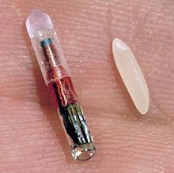

Next, we use decision-making tools to analyze our business intelligence and our expected Return on Investment (ROI). Research on the market and our competitors show that there is a niche that we can fill. The historical data suggest that we have an abundant supply of components of a mature technology. This keeps cost of procurement and manufacturing processes low.

We have several considerations to determine the cost effectiveness of this business endeavor. We calculate estimations of the Net Benefit, the ROI, the Present Value (PV), the Cost‑Benefit ratio, and the Profitability Index, shown below:

Market Volume = $2.5 million, estimated market volume (first year)

Target Volume = 25,000 units (1% of market volume)

Product Price = $100 per unit

Total Benefits = $2.5 million (25,000 units * $100 per unit) from product sales

6-Months Startup Costs = $100,000 for research, development, equipment, and facilities

6-Months Production Cost = $500,000, cost to produce 25,000 units * $20 unit cost

Total Cost (first year) = $600,000 (6-Months Startup Costs + 6-Months Production Cost)

Depreciation = $50,000 (10% per annum of capital equipment and inventory)

Useful life = Six-year predicted useful life of product and vehicle

Net Benefit = Total Benefits - Total Cost - Depreciation / Useful life

Net Benefit = $1.9 million ($2.5 million - $600,000 - $50,000 / 6 years)

Return-On-Investment = Net Benefit / Total Initial Investment

Return-On-Investment = 317% ($1.9 million / $600,000)

Payment = $54,000 annum = $4,500 Monthly ($600,000 loan at 3% SBA‑sponsored rate)

Present Value = Payment * - (1 - (1 + interest) n) / interest

Present Value = ($54,000 * - (1 - (1 + 6%) 30 years) / 6% SBA‑sponsored rate)

Present Value = -$5,169,142 = ($54,000 * - 95.724) = ($54,000 * - (5.743 / 6%))

Cost benefit ratio = Total benefits / Total costs

Cost benefit ratio = 3.13:1 = $1.9 million / $600,000

Profitability index = 35.185 = $1.9 million (Present value) / $54,000 (investment)

Profitable the first year (five months after production starts)

We show the computations for the six‑month start‑up in the first year, then the subsequent years of production.

To prepare the Business Plan, we accumulate our business intelligence and all our research data to develop the strategy to start-up this business and the processes to maintain a successful business operation. Further details are explained in the proceeding Implementation Plan and the proceeding Marketing Plan.

Implementation Plan

From the nature of Smart Key, we can see it is an improvement upon existing car alarm technology, which makes it an incremental innovation. We would follow the product cycle of incremental innovation process to plan for the implementation of the final product.

Based on the model of Cyclic Incremental Innovation Process (Betz, 2011), the whole process is divided into four stages: Research, Product Planning, Product Design, and Product Production.

Research (3 months)

In the research phase, we would start the research into two parts, the first is to have research on similar product designs such as On Star, myChvrolet apps to understand if Smart Key needs more features, and the second part is to have research on what technology solutions can be used to implement the function we want based on our research on the first part.

Some technology can provide similar function that can notify car owners when car alarm is triggered by sending SMS or pushing notification to car owner’s smart phone. But this kind of technology requires the car itself to equip mobile data connectivity, such as 4G/3G network. This kind of technology not just increases the cost of making the alarm system, but also increases the cost of ownership because the data network costs money to the owner too. And it may not be reliable if the data connection is not stable either for owner’s device or the car itself.

So from the research of our counterpart’s technology, we found that to implement Smart Key is to go with old fashion, low cost, reliable Analog RF (Radio Frequency) solution to implement our product.

In the stage two, we would have research on how to design our product. Since we want to implement the product with lower cost and with higher computability, we won’t do the radical change to the current car alarm system. Instead, we would add several more components to the current car alarm technology to make it more compatible and reliable. The easiest implementation should be adding a one way communication system to the current car alarm system.

Product Planning (2 weeks)

In this phase, we gather all research information along with all our project documents, to find out how we design and produce the product.

Within this two weeks, meetings with executives, technology team, and marketing team will be held to discuss a final draft and plan of what is Smart Key, how we are going to design it, how we are going to mass produce it, and how we are going to market it. During the meetings, initiatives might be changed in discussion, but after every department buy in to this whole project, we can start the next phase which is Product Design, and meanwhile, marketing team can start working on how to promote our future product.

Product Design (2 Months)

Based on the results from research, we will implement a one-way RF communication system parallel with the existing car alarm system.

There will be two sub-system we need to implement: the on-car system and the hub.On-car system is a RF broadcaster. It is parallel with the existing car alarm system and it will be triggered by the car alarm system. When car alarm is triggered, it will generate a signal to trigger the RF broadcaster. Broadcaster will send high power signal its ambient surroundings (500 meters). The other system, the hub, which will stay with the car owner, will sound and vibrate when it catches the signal broadcasted by the RF broadcaster.

The hub needs to have a RF receiver to catch the signal from broadcaster. It would need to consume certain amount of power, so it needs an accurate receiver and extra battery, and also need to be charged from time to time. During this phase, we come up with the prototype circuit board and demonstrate the functionality. After that, we would characterize all performance data and system requirement, and we will finalized our system design schematic, so that we can start a request for proposal to our manufacturers.

Product Productions (4 Months)

This phase will be an iterative stage. We would initiate request for proposal to several manufacturers, finalize our contract, and then start working with the manufacturer.

We would first ask for production prototype, and run system tests, sanity tests and performance test to find issue of the current product. If issues are found, we either go back to the original design to fix the issue if it is a system issue, or request change in manufacturer if it is production issue. We keep this process for several iteration for Quality Assurance (QA).

After the final product acceptance, we can officially start the massive productions.

Marketing Strategy

We want to inform our customers the importance of having our alarm system too protect your car. We will highlight our overpriced competitors and exploit the faults of average alarm systems. The strategy will be based on the promise that we give our consumers maximum awareness of the car they love with a price anyone can afford.

Marketing Targets

The marketing target for this product will be broken into customers, stakeholders, car manufactures. These primary targets will be the key to a success impact with-in the industry, and allow us to continued profit and grow. Each target will be introduced to the product in different light, using different forms of media. The following will breakdown and narrow the specific targets for our marketing strategy.

Customers

Our primary target age for customers between the ages 25 and 50, this is the primary years a person would likely be able to afford to buy a car they value enough to secure. To young and the marketing tactic could be wasted, too late and we may be trying to persuade consumers set in their ways. Target demographics of the consumers is not a huge factor with our product, however the economic status will. We want to focus our efforts on the middle-class but not exclude the high-class and low-class. This will allow us to focus on the masses of the population for our product.

Stakeholders

We need investors’ bottom line, what type of investors can play a factor in the long run when it comes to their loyalty. Since we just need to get the product funded we choose to keep our target for our stakeholders’ board.

Partnership

We are targeting car making manufactures, to host our product in their new cars. This doesn’t mean we will be limited to only car manufactures, but we can also use the same market strategy to target to aftermarket parts companies.

Marketing Materials & Promotions Strategy

A website will be constructed displaying our product and some technical aspects. A list of cars that the product will be able to support, video presentation, etc. Once a partnership is made we will display that manufacture on our website with links to their website. We won’t do commercials until we have a partner due to funds, but we will hit car and security magazines, as well internet ads on related sites. We invade social media to assist with our marketing such as Twitter, Face book, and Instagram. We will focus our efforts on Promotions such as car shows and security events. We will evaluate and grow or shrink our marketing materials and promotions strategy as or profits dictate. (Lavinsky, 2013)

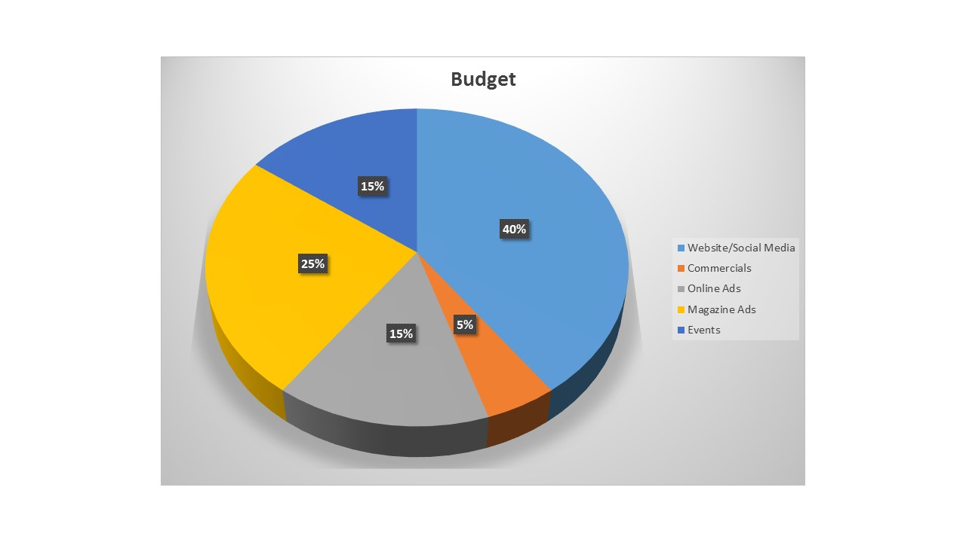Market Budget

Measured Success

When it comes to measuring success of our business we must think internally and externally. Internally we must considered our mission, we must also consider the work atmosphere, our employees, and the growth of our business. Externally we must consider how we want our business to impact the market, and our consumers. Profit of course is the overall goal and dictator of our success, but each small aspect must be measured to ensure profits steadily increase.

Internally

Employee Appreciation and work atmosphere

We want our employees to enjoy helping those who couldn’t afford a high-tech security system for one of their most valuable assets. We want the employees to want to perform the best job they can, and want to be on time and ready to make a difference. We will measure the success of this factor by. (Alter, n.d.)

Reviewing the amount of complaints to HR (the number must be relatively low compared to the amount of employees)

Review the work environment first hand (Talk to employees and get a firsthand feel)

Conducting and employee surveys and post-employment surveys

Review employee incidents

Review retention percentage

Growth

The launch of the Smart Key is just the beginning of the products we want to impact society. We will continue to add features that are compatible with other technology, and new innovations. We also will pull in more partners in the future and more investors for future products, to measure the success of our growth after the launch of this product we will measure

How many new investors have we added within the last year

How many new features have we added to the Smart Key

What accommodations did we make to produce more Smart Keys

External

Impact to Market

Our business will need to impact the market in order to be aggressive against our competitors and for long term growth. This means taking a huge percent of the competitors’ shares and eventually taking over 50% of the market. This goal however would be unreasonable within a short time frame, but this will be the final goal for our business which will be monitored in the following outlines:

1st year Market share is at least 20%

2nd year Market share increases (30%....40%)

3rd year Market share increases (50% or greater)

The numbers will be revaluated after each year to ensure we have the best opportunity to succeed in the long run.

Customers

The consumer is the center of our profits. They are why we do what we do. How consumers are see us and how they see our products /services is a direct reflect of our pocket books. This will or indicators for success will be the following:

Reviewing customer surveys (Must meet a 80% or higher of highest scores)

Comment on our Social media

Ratings on third party sites

Customer loyalty (reviewing membership plans and return buying, and referrals)

Turnaround time and customer satisfaction to complaints

Reviewing the amount of sales and returns, new customers

The total success of our product after launch will lean on the success of the many factors of our business. The list above is only the tip of the iceberg for the near future, but as we grow we may be narrowing down the boarder list into multiple indicators. Reevaluating goals will also be a key for measuring our success to make them realistic and obtainable.

Conclusion

Considering above explained business case, our team has engaged in delivering high quality product for cheaper price. we are also focusing on future opportunities to expand our business to different areas. We are also focused on increasing our production facility to overcome our demand and supply issues in future.

# References

Azambuja, M. (2009). *(2009, 30). A*. Retrieved from http://www.ndltd.org/service providers/scirus-etd-search.

Auto Sales. (n.d.). Retrieved April 7, 2015, from <http://online.wsj.com/mdc/public/page/2_3022-autosales.html#autosalesE>

Chandra, C., & Kachhal, S. K. (2004). *Managing health care supply chain: trends, issues, and solutions from a logistics perspective*. In Proceedings of the sixteenth annual society of health systems management engineering forum, February (pp. 20-21).

*FBI releases preliminary semiannual crime statistics for 2014.* (2015). (). Lanham: Federal Information & News Dispatch, Inc. Retrieved from <http://search.proquest.com/docview/1648385374?accountid=145333>

John S., Robert, J., & Stephen, S. (2009). *Systems & Analysis Design in a Changing World*. 5th edition, U.S.A.

Gupta, U. (2009) ISBN 9 780130 108579 Information Systems. Security In The 21st

Century

Laudon, K. C., & Traver, C. G. (2012). *Management Information Systems.* (12th, Ed.) Prentice Hall.

Lavinsky, D. (2013, June 7). Marketing Plan Template: Exactly What To Include. Retrieved April 7, 2015, from <http://www.forbes.com/sites/davelavinsky/2013/09/30/marketing-> plan-template-exactly-what-to-include

*Radio-frequency identification - Wikipedia, the free encyclopedia*. (2015, April). Retrieved from http://en.wikipedia.org/wiki/Radio-frequency_identification

Research and Markets: Global Car Security Systems Market Outlook 2019 - Alarm, Immobilizer, Remote Keyless Entry (RKE) & Central Locking System. (n.d.). Retrieved April 2015, from <http://finance.yahoo.com/news/research-markets-global-car-security-> 142600284.html